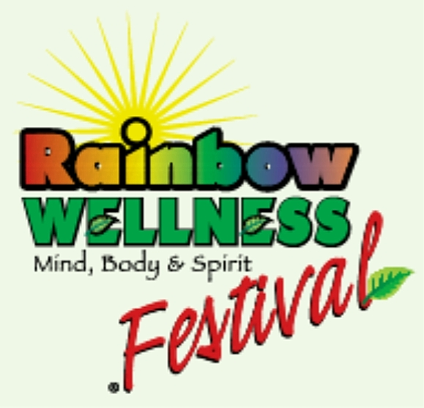
A color keepsake program
will be given to each attendee.

Five-minute Ceremonies are a unique part of the Rainbow Wellness Festival Experience!

SATURDAY SCHEDULE
10:00 Opening Ceremony

10:45-11:30 Mini Workshop - Affirmative Prayer
Rev. Carolyn Harvill
Learn the 5-step process to create Affirmative prayer. Get a quick look at Science of Mind. “There is Power in the Universe and we can use it.” At Louisville Center for Spiritual Living, we thrive on recognizing and revealing the Spiritual nature of all.

11:45-12:30 Mini Workshop –
Components of Skin Care Products
David G. Changaris, MD, CEELA Naturals.
In the U.S., every woman puts about 4-8 pounds of triethanolamine on her skin every year. What does this mean and why should you care? Is it possible to buy a shampoo without laureth sulfates? Should you try? And just what does your skin want? A physician-neurochemist discusses how these answers touch the mind through our skin.

12:45 Ceremony

1:15-2:00 Mini Workshop –
Sound Healing with Tuning Forks
Nanci Wesling, featherhawk
Experience a live demonstration using the ancient Solfeggio scale tuning forks and learn about the history of these long-lost frequencies. These sacred sounds ‘tune up’ your body’s energy centers, the Chakras, healing and harmonizing Body, Mind and Soul. As your body is tuned, balance and well-being are restored and you experience relaxation and stress relief.

2:15-3:00 Mini Workshop - Herbal Supplements and Remedies: Cautions from a Medicine Woman
Jenna “Raven” Prince, Sacred Cure
Information and responsibilities in using herbal supplements and remedies. Extend your knowledge of everyday herbs and their uses, along with understanding into the world of sacred native herbals. Fun recipes of simple salves, body and room spritzers for the holidays!

3:15 Ceremony

3:45-4:30 Mini Workshop - Polarity Therapy: Balancing the Energies of Life
Ann Rudrauff, MA, APP, Go 4 It!
A sampler of the profound practice of Polarity Therapy. Interactive session to “feel the body work,” stretch in the Ayurvedic elements like never before. understand the ENERGY of foods and natural cleansing, and get in touch with Spirit. Abundant wellness for all! Explore prevention and renewal choices for optimal well being!

5:45 Closing Ceremony

SUNDAY SCHEDULE
12:00 Opening Ceremony

12:30-1:15 Mini Workshop – Understanding Your Dreams
Jesse Reece, School of Metaphysics
Introduction into the Universal Language of Mind, the language of Dreams. Basic description and explanation of the structures of mind, how and why we dream, and what to do with our dream messages. Using dreams for acceleration and evolution, individually and collectively.

1:30 Ceremony

2:00-2:45 Mini Workshop –
Simple Acupressure for Self Help
Martha Graziano,
Classical Acupuncture & Herbs
Self help for headaches, congestion, simple aches and pains, etc., adapted to the needs of those present in the class. Includes a short introduction to how acupressure/acupuncture works. This will be a participatory class where everyone can learn some acupressure points.

3:00 Ceremony

3:30-4:15 Mini Workshop - The Wise and Hows of Essential Oils
Mary H. Clark, Center of Essence
What are essential oils? How do they really work? And do they? *Wisdom in prevention of dis-ease *Wisdom in wellness *Creating a healthy environment at home, work or away

5:00 Raffle

5:45 Closing Ceremony

VENDORS
BodyTalkWorks
Mollie Yunker
www.bodytalkworks.net
502.550-2719
Mollie@bodytalkworks.net
BodyTalk sessions available. Please come by and learn a healing technique to optimize and balance your brain.

CEELA Naturals
David Changaris, MD
www.ceelanaturals.com
502.584.6855
dgcmd@bellsouth.net
Vegan, common allergen-free skin care (surfactant-free). Developed by a physician neurochemist to nourish and moisten skin. Bioavailable and petrochemical free!

Elzy Enterprises LLC / Quantum Biofeedback
Jane Elzy
JaneElzy@aol.com
Sample introductory sessions to introduce biofeedback and its ability to help reduce stress, as 90% of all disease is caused by stress.

featherhawk essences / EarthGifts Jewelry and Healing Tools
Nanci Wesling
www.featherhawk.com
812.949.0478, 502.435.6445 (cell)
nanci@featherhawk.com
Discover how featherhawk essences: restore sanity in a crazy world… one drop at a time! Get an ‘energy tune-up’ with the Solfeggio Scale Tuning Forks. Stock up on EarthGifts jewelry and healing tools - they make great holiday gifts!.

Go 4 It! Polarity Therapy - the Totality of Wellness, Body, Mind, Spirit, Abundance
Ann Rudrauff, MA. APP
www.sturz@mymangosteen.com
502.419.1702 (cell), 502.899.9229 (office)
gogoann@bellsouth.net
Feel the calmness and peace, learn wellness integration and balancing energy for prevention and renewal. Polarity Therapy is energetic body work, food awareness, gentle stretching postures, positive life intentions, and creating abundance in all areas of life. Experience, Learn, Educate.

Louisville Center for Spiritual Living
Rev. Carolyn Harvill
www.LCSLonline.org
713.686.5418
RevCarolyn@LCSLonline.org
Metaphysical Books, Introduction to Science of Mind.

Mystyk River Retreat Center
Marjorie Bowers and Garnet Worthington
502.732.9938
Mbwrs4@aol.com
Mystyk River Retreat Center provides holistic energy services through Therapeutic Massage, Craniosacral Therapy, Lymph Drainage Therapy, Quantum Touch, Reconnective Healing, Core Transformation, detoxification, and nutrition counseling. Clients are welcome to schedule individual sessions or customized packages that encourage balance and heighten a sense of well-being.

Pavitra
Allison and Chris Singler
louisvillemojo.com/IonicWoman
502.459.1462
casingler@att.net
Products by EcoQuest including whole house air purifiers, Ionic Foot Spa - Body Detox, Wood Work by Chris Singler.

School of Metaphysics
Jesse Reece
www.som.org
502.452.2501
louisville@som.org
The School of Metaphysics is an educational institute devoted to teach the structure, use and practical application of Mind and consciousness through books, tapes/CDs, Classes and lectures.

Sacred Cures
Jenna Raven Prince
502-231-5072
ravenbloodstone@hotmail.com
Holistic tonic & tea remedies, herbal & organic products for the bath, body, & the entire family handmade by a Cherokee medicine woman. We also carry a line of sacred native supplements.
Center of Essence
Mary Clark
mhclark17@att.net
Experience the wonderful fragrances of Young Living Essential Oils and learn how they can help you regain and maintain health and well being.

